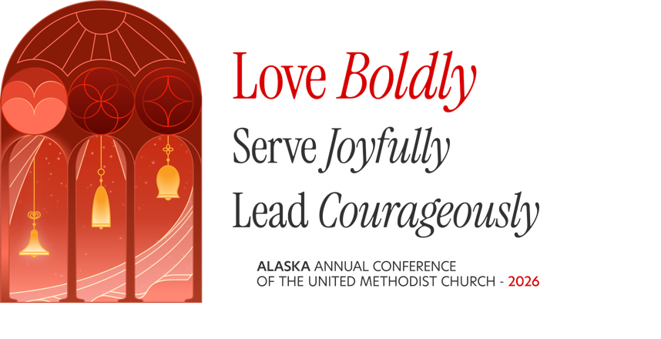

Love Boldly
Acts 4:31: “When they had prayed, the place in which they were gathered together was shaken; and they were all filled with the Holy Spirit and spoke the word of God with boldness.”
The disciples had every reason to be cautious.
They had seen what happened to Jesus. They had experienced opposition. They knew that speaking openly about their faith could cost them something. And yet, when they gathered together, they did not pray for an easier road. They prayed for boldness.
And God answered.
Notice what happens: they pray, they are filled with the Holy Spirit, and then they speak with boldness. Their courage is not about being loud or certain or fearless. It comes from knowing that they are not doing this work alone.
That is an important word for this local church today.
We are living through a time of transformation. Some things that once felt familiar no longer are. We are asking hard questions about who we are, how we serve our communities, how we use our resources, and what faithfulness looks like in a changing church.
It can be tempting, in seasons like this, to protect what we know. To retreat into what is comfortable. To avoid difficult conversations.
But the church in Acts shows us another way.
We can love boldly.
Bold love tells the truth without losing compassion.
Bold love makes room for people who have been standing at the edges.
Bold love is willing to change when change helps us become more faithful.
Bold love does not require us to have every answer before we take the next faithful step.
And perhaps most importantly, bold love begins in prayer.
Before we ask what we should do, we remember whose church this is. Before we try to solve everything, we make room for the Holy Spirit. Before we speak, we listen.
At this Charge Conference, may we not simply conduct the business of the church. May we remember the purpose of the church: to love God and love our neighbors.
The place where the disciples prayed was shaken. Perhaps transformation begins the same way for us—not with certainty, but with a willingness to be shaken loose from whatever keeps us from loving boldly.
So let us pray for the same gift they received:
Not certainty, but courage.
Not control, but trust.
Not comfort, but faithfulness.
Not fear, but bold love.
Because the world does not need the church to be perfect.
The world needs the church to show up, tell the truth, make room, and love boldly.
Question: In what ways is this congregation showing up, telling the truth, making room, and loving boldly?
Prayer for the celebrations of this ministry.

