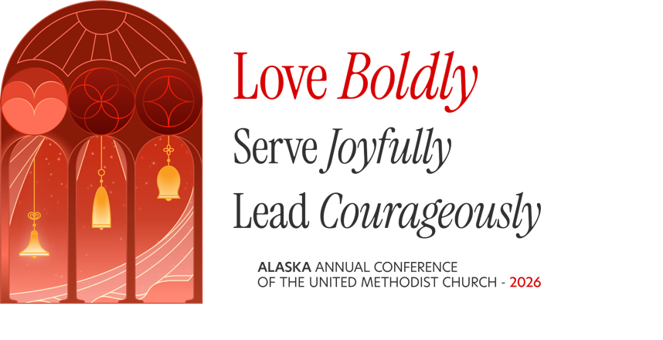

ORDER OF WORSHIP
WELCOME, INTRODUCTIONS & LAND ACKNOWLEDGMENT Pastor
CALL TO WORSHIP Superintendent or Presiding Elder
One: These are the days we have been given.
Many: These are the communities entrusted to our care.
One: We come with questions, with weariness, and with hope.
Many: We come trusting that the Holy Spirit is still at work among us.
One: When the early church faced uncertainty and opposition, they prayed.
Many: And the place where they gathered was shaken.
One: They did not pray for an easier road. They prayed for courage.
Many: Give us courage to tell the truth, to speak plainly, and to do what is right.
One: They did not carry the ministry alone. The whole community gathered, prayed, and became responsible for the witness.
Many: We are the church together. We will show up, lead where we are, and care for one another.
One: For Christ calls us to love—not only when it is comfortable, but especially when it is difficult.
Many: We will choose love. We will choose truth. We will choose repair.
One: So let us pray first. Let us listen deeply. Let us speak honestly. Let us trust the Spirit.
Many: And let us love boldly.
All: Holy Spirit, shake us awake. Transform us from within. Make us courageous witnesses to the love of Christ in our churches and communities. Amen.
SCRIPTURE: Acts 4:31 Lay Member
"When they had prayed, the place in which they were gathered together was shaken; and they were all filled with the Holy Spirit and spoke the word of God with boldness."
DEVOTIONAL Superintendent or Presiding Elder
CALL TO ORDER Superintendent or Presiding Elder
Election of Recording Secretary
The Recording Secretary takes ‘Quick Minutes,’ documents attendance, and records items for vote. Voting eligibility will be clarified at this time.

Items for vote by the Annual Charge Conference (having already been approved locally):
- Pastor or Pastors' Salary Package for 2027
- Candidacy (as needed)
- Initial Candidacy Recommendation
- Continuation of Candidacy Recommendation
- Nominations and Leadership Development Report
- Report and Election of Leaders for 2027
- Lay Ministry Annual Report and Renewal (as needed)
  - Recertification of Lay Servant Ministers, Lay Speaker, and Certified Lay Ministers
- Membership Report or Membership Removal of Inactive Members (as needed)
  - Reading of Names: First Year & Second Year- As Needed
- Other Business Requiring Votes (Pre-approved Items)
- Mission Aid and Equitable Salary Churches - Salary Subsidy Request approval (as needed).

Accountability Questions:
- Have the church's financial activities been formally reviewed or audited for 2024?
- Are your corporate status (501c.3) and property tax exemptions current?
- Is your insurance current and paid? Does it cover all of your buildings including new additions? Are coverage amounts still adequate to rebuild in the wake of a tragedy?
- Does your church have a current and enforced "Safe Ministries" policy? Have you read the Alaska Conference Safe Ministries Policy that was adopted at Annual Conference in 2025? Have you updated your local church with the items that the Annual Conference 2025 adopted to maintain compliance with insurance and General Board of Global Ministries requirements?
- Are your church’s required biennial national background checks and annual trainings current for volunteers and staff?
- Is your church current on its apportionments?

Highlights from M.I.L.E. Assessment & Pastor & Congregation
Celebrations of the Past Year

Church Commitments &
Emerging Visions for Coming Year

SHARING OF OUR GIFTS Pastor & Congregation
Offering prayers, presence, gifts, service, and witness.

Closing Thoughts & Adjournment

SENDING FORTH Superintendent or Presiding Elder
Prayer of Sending Forth
Holy God,
you have gathered us here,
and now you send us forth.
Send us with hearts made wider by your love,
with courage to love boldly,
and with eyes open to see Christ
in the people we meet along the way.
When the work feels difficult,
give us patience.
When the path is uncertain,
give us courage.
When we are tempted to turn inward,
remind us that your table has room for everyone.
Send us –
to meet you in spaces we do not yet know,
to be people who show up—
who listen, who serve, who welcome,
and who make room for one another.
May the Holy Spirit fill us with boldness,
as you filled those first disciples,
so that our lives may bear witness
to the love we have received.
Go with us now.
Bless the ministry before us.
Strengthen our church.
Encourage our leaders.
And help us to be faithful stewards of the gifts
you have placed in our hands.
May we leave this gathering not simply renewed,
but ready—
ready to love boldly,
serve joyfully,
and follow Christ wherever the Spirit leads.
In the name of Jesus Christ,
who calls us to love God
and to love our neighbor as ourselves.
Amen.

