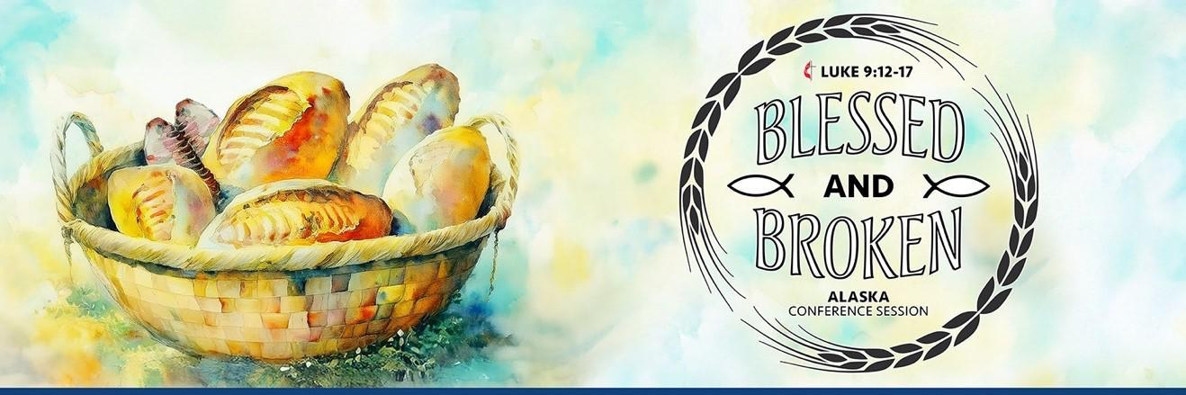

54th Session of the Alaska Annual Conference
May 29-31, 2025

PRECONFERENCE WORKSHOPS

THURSDAY|MAY 29, 2025

9:30 Opening Devotional | Rev. Karen Hernandez| Sanctuary
https://alaskaumc.org/2025-annual-conference/

14:00 Laity Session|Melanie Venables, Conference Lay Leader| Sanctuary
https://alaskaumc.org/2025-annual-conference/

REGULAR SESSION

FRIDAY | MAY 30, 2025
8:30 Annual Conference Opening Worship | Bishop Cedrick Bridgeforth
https://alaskaumc.org/2025-annual-conference/

10:00 Land Acknowledgement, Welcome, and Opening Prayer | Bishop Cedrick, Rev. Emily Carroll & Rev. Bennie Grace Nabua
https://alaskaumc.org/2025-annual-conference/

10:15 Opening Plenary Session
https://alaskaumc.org/2025-annual-conference/

VPoll Instructions and Practice Vote | Greg Driscoll
Opening Motion | Rev. Nico Reijns
Nomination of Conference Secretary | Rev. Kristi McGuire
Petition #1 – Rules Committee Recommendation & Safe Ministry Guidelines |David Means & Brant Henshaw
Petition #2 – Pension | Bruce Galvin
Recommendation for Minimum Salary | David Means
Presentation of Nominations Report | Rev. Kristi McGuire

12:00 Lunch

13:00 Plenary Session Two
https://alaskaumc.org/2025-annual-conference/

Prayer – Rev. David Owsley
Petition #3 – Church Property Policy and Sanctuary Alignment | Rev. Kristi McGuire
Youth Address (video)
Petition #4 - Late Breaking Petition | Jo Anne Hayden
Vote to allow petition (⅔)
Petition #4 - Complaint, Investigation, and Judicial Proceedings | Rev. Kristi
McGuire, Rev. Bob Jones, and Jo Anne Hayden

15:30 Plenary Session Three
https://alaskaumc.org/2025-annual-conference/

Prayer – Rev. Lydia Wilson
Nominations Report | Rev. Kristi McGuire
Constitutional Amendments | Rev. Jim Doepken & Jo Anne Hayden
Circle of Indigenous Ministries – Truth-telling & Native Ministries Address |Rev. Dr. Allen Buck
Greater Northwest Cabinet Experience |Bishop Cedrick & Rev. Mark Galang

18:00 Dinner with Retirement Recognition & Awards |MAC

19:00 Memorial Service | Rev. Lisa Talbott | Sanctuary
https://alaskaumc.org/2025-annual-conference/

SATURDAY| MAY 31, 2025
8:30 Opening Devotion | Sara Goetze, Oregon-Idaho Conference Treasurer
https://alaskaumc.org/2025-annual-conference/

9:00 Closing Plenary
Prayer – Lonnie Brooks (video)
General Conference Legislation | Rev. Jim Doepken & Jo Anne Hayden
Constitutional Amendment Ballot #1: Worldwide Regionalization
Constitutional Amendment Ballot #2: Paragraph 4, Article 4 Ratification
Constitutional Amendment Ballot #3: Article V: Racial Justice
Constitutional Amendment Ballot #4: Paragraph 35

Closing Motion | Rev. Meghan Lambert

11:30 LUNCH

12:30 Commissioning Service | Bishop Cedrick Bridgeforth, Rev. Kristi McGuire, Rev.
Elizabeth Schultz
https://alaskaumc.org/2025-annual-conference/

Reading of Appointments | Bishop Cedrick Bridgeforth & Rev. Kristi McGuire

Benediction & Sending Hymn | Bishop Cedrick Bridgeforth

