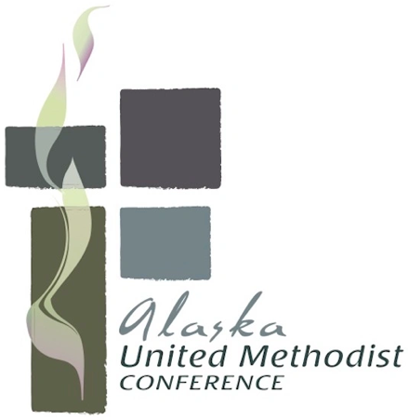
Creating a Preparedness Plan
All persons in the United States have constitutional protections, including the right to remain silent when questioned or arrested by immigration officers. Being stopped by immigration officers or other law enforcement can be frightening.
Knowing your rights and having a plan in place is helpful in preparing for this scenario.
A personal plan might include:
- Emergency contacts with phone numbers memorized. Your emergency contact needs to have contact information for your:
  - Attorney (If you don’t have a lawyer, here is a Legal Services Directory that can be used to find non-profit legal services providers nationwide.)
  - District Superintendent (clergy) and
  - Clergy (lay).
- If you have guardianship of children under the age of 18:
  - Provide your child’s school or daycare with an emergency contact to pick up your child.
  - Provide authorization in writing for your emergency contact to make medical and legal decisions for your child.
- Tell your emergency contact and other important people that they can try to use ICE’s online detainee locator to find you should you go missing or if you are detained: https://locator.ice.gov/odls/#/search
- Completing this downloadable, fillable, and printable Family Preparedness Plan.
- If you are at risk of arrest or deportation, consider additional steps you may take to secure the rights of any children and your financial assets and responsibilities.
Churches that seek to maintain protections to ensure that all community members can access essential services and support without fear of immigration-related consequences will need a plan.
A congregation plan might include:
- Protocols for having emergency contacts on file for all staff and members.
- Reviewing and discussing the UMC’s Migrant Accompaniment Guide to Supporting Migrants and Immigrants Globally
- Reviewing the Interim Guidance on Immigration Enforcement Issues document to understand congregational and individual rights and the impact of recent decisions
- Determining what protocols will be implemented to care for the vulnerable in your midst in worship, preschools, food pantries and other outward-facing ministries. For example:
  - Will you keep doors locked to provide extra safety, and how will you ask for warrants?
  - Will you provide additional information and support to persons in the ministry and community who feel unsafe?
  - Who needs to be trained on protocols?
- As helpful, use the Facilitation Guide for Congregational Conversations about Risk Discernment
- If you have food pantries, preschools or other outward-facing ministries
  - Know the Law: While ICE can take enforcement actions in sensitive locations, they are still expected to prioritize enforcement based on "common sense" and avoid disrupting essential services, particularly for vulnerable populations like children and those seeking food assistance. Familiarize yourself with any local ordinances or sanctuary policies that might offer additional protections in your area. Churches may choose to keep outside doors locked for maximum safety.
[See FEMA Guidance]
  - Offer Staff Training: Training is a part of preparedness. Ensure all staff and leaders understand how to interact with law enforcement, including knowing their rights (for example, you can ask for a warrant if they seek to enter). It may be helpful to have a protocol in place for handling such visits, ensuring the safety and privacy of individuals using your services.
  - Communicate: If your church provides ministries where vulnerable communities gather, consider offering information on their rights, connecting them to legal support, and reassuring them that your ministry exists to serve all people in need.
  - Consult Legal Counsel: Given the complexity of immigration laws and enforcement policies, please ensure that you are compliant with the law. Consult with an immigration attorney or organization to ensure you are fully prepared and up to date on the latest developments. They can offer guidance specific to your situation and help you navigate any potential challenges.

Here is some additional guidance:
- For churches: Factsheet: Trump’s Rescission of Protected Areas Policies Undermines Safety for All
- For employers: A Guide for Employers: What to Do if Immigration Comes to Your Workplace
- For schools: 10 Strategies for Schools in ICE Raid 2025
- For pre-schools: A Guide to Creating Safe Space Policies for Early Childhood Programs

